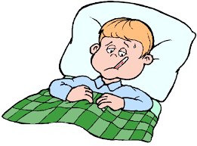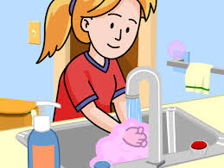

Viruses are tiny germs that we can’t see. The Coronavirus is a new virus that can make us feel unwell. Lots of people may have the Coronavirus, they might feel like they have a cold or flu.

What is the Coronavirus?



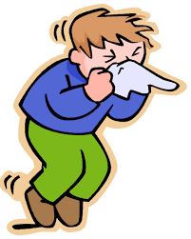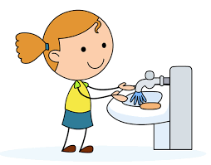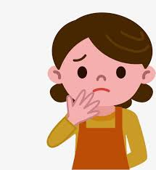[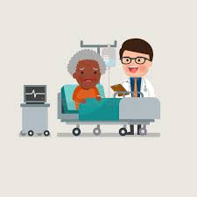](https://www.google.co.uk/imgres?imgurl=https%3A%2F%2Fthumbs.dreamstime.com%2Fb%2Fmedical-patient-grandma-being-treated-expert-doctor-african-american-people-caucasian-hospital-room-flat-design-80553700.jpg&imgrefurl=https%3A%2F%2Fwww.dreamstime.com%2Fillustration%2Fgrandma-hospital.html&tbnid=_D_gQgLKC-oUXM&vet=12ahUKEwid7v6C_57oAhXMgM4BHWWxAPUQMygbegQIARA-..i&docid=9JdlLjrymwExSM&w=800&h=800&q=doctor%20grandparent%20hospital%20cartoon&safe=strict&ved=2ahUKEwid7v6C_57oAhXMgM4BHWWxAPUQMygbegQIARA-)

There are some things we can try to do to avoid catching the Coronavirus

* Wash our hands for 20 seconds.
* Cough or sneeze into a tissue or our arm.
* Try not to touch our faces.

A few people who have the Coronavirus might feel very poorly and need to go to the hospital where the nurses and doctors can help them.

[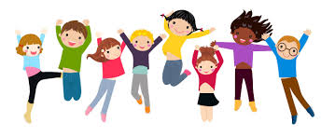](https://www.google.co.uk/imgres?imgurl=https%3A%2F%2Fclipartix.com%2Fwp-content%2Fuploads%2F2018%2F03%2Fhealthy-people-cartoon-2018-23.jpg&imgrefurl=https%3A%2F%2Fclipartix.com%2Fhealthy-people-cartoon%2F&tbnid=2oN56N_Moa7cCM&vet=12ahUKEwiehZWvhJ_oAhUU0oUKHR-uBBQQMyguegUIARCXAQ..i&docid=OXmXk_BvZJE7FM&w=2884&h=1231&q=healthy%20cartoon&safe=strict&ved=2ahUKEwiehZWvhJ_oAhUU0oUKHR-uBBQQMyguegUIARCXAQ)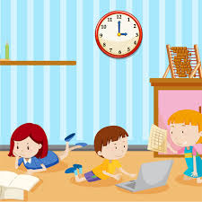

If I am worried about the Coronavirus I can ask an adult. Every day there is more information and adults are listening to advice from the Government. Following this advice will help to keep us happy and healthy.

We might have to stay home from school and work. This is okay, it is to help the stop the virus from spreading and to keep us healthy. We will be told when to go back to school and work.

We might have to stay home from school and some of the shops might shut. This is okay, it is to help the stop the virus from spreading and to keep us healthy. We will be told when to go back to school when things are normal again.