Login to a school Laptop from home

Use the link below or click the link on the Staff Links on the website
https://rds.thebeacon.kent.sch.uk/

Clicking the link will bring you to this screen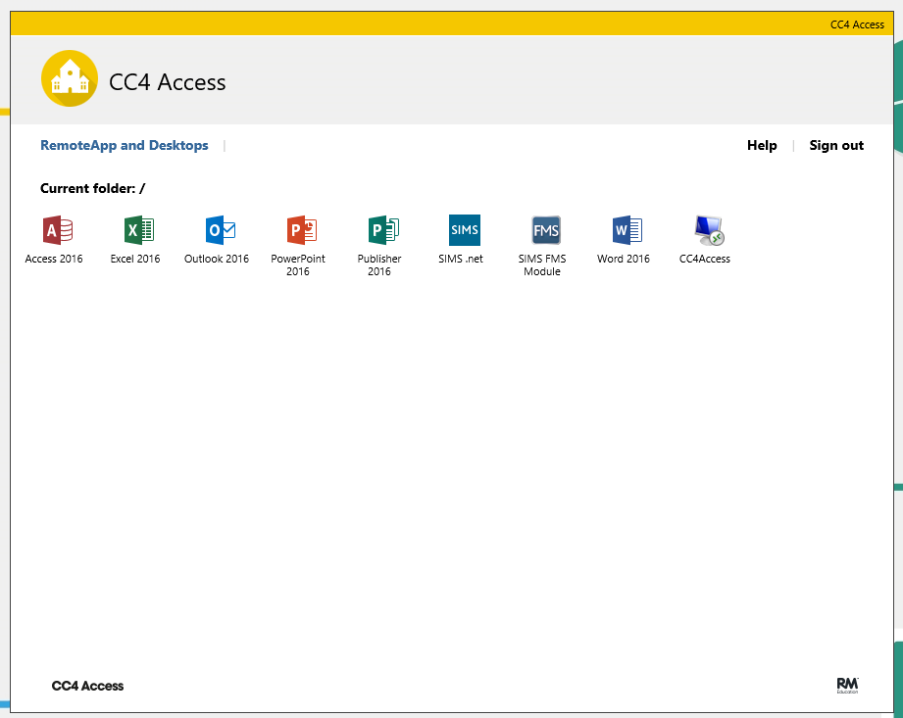
Click CC4Access
This will ask you to download a program, once done click open.

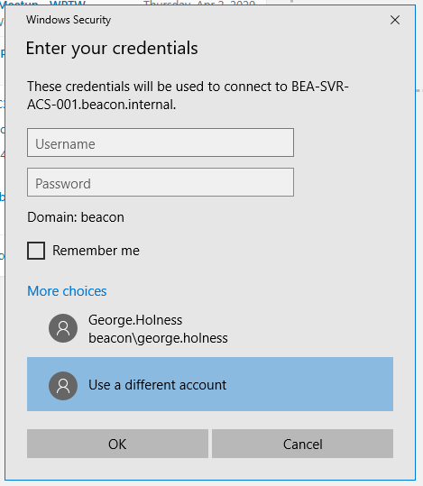
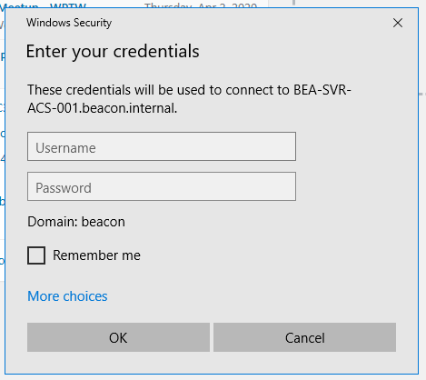
You will then be directed to login, if this is your first time you will need to click More Choices and then click Use a Different Account

Sign in using your normal login details

You will then be asked to choose a location click: Teacher PC’s if you’re a teacher
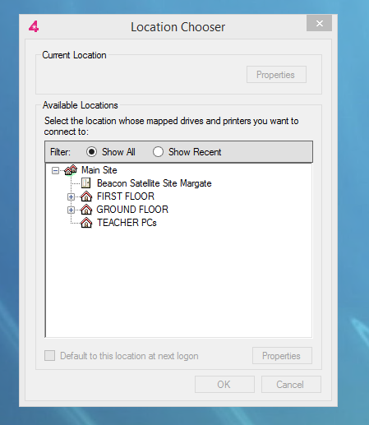

You should be now able to access your files from home.
If you find any problems please feel free to contact:
George Holness
Contact number: 07733403955
Email: George.holness@thebeacon.kent.sch.uk

