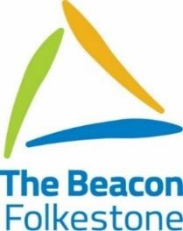

The Beacon School Leavers Destinations September 2019

2019  Leavers | Beacon Plus | EKC  Canterbury | EKC  Dover | EKC Folkestone | The Shed | Muddy Wellies | Martello Centre | NEET | Out of County | Unknown
The Beacon | 8 | 4 | 2 | 9 | 1 | 1 | 1 | 2 | 2 | 0

