Supporting Pupils with
Medical Needs
Policy

September 2018

Statement of Purpose, Definitions of Medical Conditions
The Statutory Duty of the Governing Body
Policy Implementation
Procedure to be followed when notification is received that a pupil has a Medical Condition
Health Care Plans
Individual Health Care Plancare
Roles and Responsibilities
Roles and Responsibilities continued
Process Map Flowchart
Staff Training and Support
The Pupils role in managing their own medical needs
Managing Medicines on School Premises and Record keeping
Managing Medicines on School Premises and Record Keeping Continued
Storage of Medication and Sharps Bins
Controlled Drugs
Emergency Procedures
Day Trips, Residential Visits and Sporting Activities
Confidentiality, Headlice
Pupil Individual Staff Training
First Aid
Communicable Diseases
Unacceptable Practice
Liability and Indemnity
Complaints
Medication Administration Record Chart (MARC)
Missed Dose-Medication Errors
School Nurse
Weight Concerns
Epilepsy
Staff Illness/Medication
Appendix 3 Developing Health Care Plans
Appendix 4 Sample Marc Forms
Appendix 5 Sample Height and Weight Record Chart
Appendix 6 Sample Epilepsy Recording Sheet
Supporting Pupils with Medical Needs Policy

Contents

This policy is written in line with the requirements of;

- Children and Families Act 2014 - section 100
- Supporting pupils at school with medical conditions: statutory guidance for governing bodies of maintained schools and proprietors of academies in England, DFE Sept 2014
- 0-25 SEND Code of Practice, DFE 2014
- Mental Health and behaviour in schools: departmental advice for school staff, DFE June 2014
- Equalities Act 2010
- Schools Admissions Code, DFE 1 Feb 2010

Statement of Purpose

The aim of The Beacon Folkestone, Executive Head Teacher, Senior Leadership Team and staff, is to ensure that pupils are educated in an environment that is conducive to well-being both physical and mental.

This policy is supported by the following school policies;

Medical and Health Policy (including first aid)/Early Years/Off-Site Visits Policy/Risk Assessments/Safeguarding, Absence and Ill Health Policy.

This policy has been developed from information received from the Local Authority, Parents and Carers, Annual Reviews, Educational Health Care Plans, School Nurse, Governors, and external professionals.

Definitions of Medical Conditions

Pupils' medical needs may be broadly summarised as being of two types:-

Short-term: Affecting their participation at school because they are on a course of medication - please refer to Absence and Ill Health Policy.

Long-term: Potentially limiting access to education and requiring on-going support, medicines or care while at school to help them to manage their condition and keep them well, including monitoring and intervention in emergency circumstances. It is important that parents feel confident that the school will provide effective support for their pupil's medical condition and that pupil’s feel safe.

Some children with medical conditions may be considered disabled. Where this is the case governing bodies must comply with their duties under the Equality Act 2010. Some may also have Special Educational Needs and Disability (SEND) and may have a Statement or Education, Health and Care Plan (EHCP) and Health Care Plan. Where this is the case this policy should be read in conjunction with the 0-25 SEND Code of Practice and the school's SEND policy / SEND Information Report and the Individual Healthcare Plan will form part of the EHCP.

The Statutory Duty of the Governing Body

The governing body remains legally responsible and accountable for fulfilling their statutory duty for supporting pupils at school with medical conditions. The governing body of The Beacon Folkestone complete this by;

Ensuring that arrangements are in place to support pupils with medical conditions. In doing so, the aim is to ensure that such pupils can access and enjoy the same opportunities at school as any other pupil.

Taking into account that many medical conditions that require support at school will affect quality of life and may be life-limiting. Some will be more obvious than others and therefore the focus is on the needs of each individual pupil and how their medical condition impacts on their school life.

Ensuring that the arrangements give parents and pupils confidence in the school's ability to provide effective support for medical conditions, should show an understanding of how medical conditions impact on a pupil's ability to learn, as well as increase their confidence and promote self-care. We will ensure that staff are properly trained to provide the support that pupils need.

Ensuring that no pupil with a medical condition is denied admission, or prevented from taking up a place in school because arrangements for their medical condition have not been made. However, in line with safeguarding duties, we will ensure that pupils' health is not put at unnecessary risk from, for example, infectious diseases, and reserve the right to refuse admittance to a pupil at times where it would be detrimental to the health of that pupil or others to do so.

Ensuring that the arrangements put in place are sufficient to meet our statutory duties and ensure that policies, plans, procedures and systems are properly and effectively implemented.

Developing a policy for supporting pupils with medical conditions that is reviewed regularly and accessible to parents and school staff (this policy).

Ensuring that the policy includes details on how the policy will be implemented effectively, including a named person who has overall responsibility for policy implementation (see section below on policy implementation B1).

Ensuring that the policy sets out the procedures to be followed whenever the school is notified that a pupil has a medical condition (see section below on procedure to be followed when notifications is received that a pupil has a medical condition B2).

Ensuring that the policy covers the role of Individual Healthcare Plans, and who is responsible for their development, in supporting pupils at school with medical conditions (see section below on individual healthcare plans B3).

Ensuring that the school policy clearly identifies the roles and responsibilities of all those involved in arrangements for supporting pupils at school with medical conditions and how they will be supported, how their training needs will be assessed and how and by whom training will be commissioned and provided (see section below on staff training and support B4).

Ensuring that the school policy covers arrangements for pupils who are competent to manage their own health needs and medicines (see section below on the pupil's role in managing their own medical needs B5).

Ensuring that the policy is clear about the procedures to be followed for managing medicines including the completion of written records (see section below on managing medicines on school premises B6).

Ensuring that the policy sets out what should happen in an emergency situation (see section below on emergency procedures B7).

Ensuring that the arrangements are clear and unambiguous about the need to support actively pupils with medical conditions to participate in school trips and visits, or in sporting activities, and not prevent them from doing so (see section on day trips, residential trips and sporting activities B8).

Considering whether to;

- Develop transparent healthcare plans in conjunction with the Local Authority for pupils with life-limiting conditions who use home to school transport.
- Purchase defibrillators and train staff in the use of them.
- Once regulations are changed consider holding asthma inhalers for emergency use.
- Ensuring that the policy is explicit about what practice is not acceptable (see section on unacceptable practice). Ensuring that the appropriate level of insurance is in place and appropriate to the level of risk (see section on Liability and Indemnity).
- Ensuring that the policy sets out how complaints may be made and will be handled concerning the support to pupils with medical conditions (see section on complaints).

Policy Implementation

The statutory duty for making arrangements for supporting pupils at school with medical conditions rests with the governing body. The governing body has conferred the following functions of the implementation of this policy to the staff below; however, the governing body remains legally responsible and accountable for fulfilling our statutory duty.

The overall responsibility for the implementation of this policy is given to Heads of Education. They will also be responsible for ensuring that sufficient staff are suitably trained and will ensure cover arrangements in cases of staff absences or staff turnover to ensure that someone is always available and on-site with an appropriate level of training.
The Heads of Education will be responsible for briefing supply teachers, overseeing risk assessments for school visits and other school activities outside of the normal timetable and for the monitoring of individual healthcare plans.

School staff which include, Teachers/School Nurse/Medication Champion/First Aiders will be responsible in conjunction with Parents/Carers, for drawing up, implementing and keeping under review the individual healthcare plan for each pupil and making sure relevant staff are aware of these plans.

All members of staff are expected to show a commitment and awareness of pupil's medical conditions and the expectations of this policy. All new members of staff will be inducted into the arrangements and guidelines in this policy upon taking up their post.

Procedure to be followed when notification is received that a pupil has a medical condition

This covers notification prior to admission, procedures to cover transitional arrangements between schools or alternative providers, and the process to be followed upon reintegration after a period of absence or when pupils' needs change. For pupils being admitted to The Beacon Folkestone for the first time with good notification given, the arrangements will be in place for the start of the relevant school term. In other cases, such as a new diagnosis or a pupil moving to The Beacon Folkestone mid-term, we will make every effort to ensure that arrangements are put in place within 48 hours where appropriate.

In making the arrangements, we will take into account that many of the medical conditions that require support at school will affect quality of life and may be life-threatening. We also acknowledge that some may be more obvious than others. We will therefore ensure that the focus is on the needs of each individual pupil and how their medical condition impacts on their school life. We aim to ensure that parents/carers and pupils can have confidence in our ability to provide effective support for medical conditions in school, so the arrangements will show an understanding of how medical conditions impact on the pupil's ability to learn, as well as increase their confidence and promote self-care.

We will ensure that staff are properly trained and supervised to support pupils' medical conditions and will be clear and unambiguous about the need to support actively pupils with medical conditions to participate in school trips and visits, or in sporting activities, and not prevent them in doing so. We will make arrangements for the inclusion of pupils in such activities with any adjustments as required unless evidence from a clinician such as a GP states that this is not possible. We will make sure that no pupil with a medical condition is denied admission or prevented from attending the school because arrangements for supporting their medical condition have not been made. However, in line with our safeguarding duties, we will ensure that all pupils' health is not put at unnecessary risk from, for example infectious disease. We will therefore not accept a pupil in school at times where it would be detrimental to the health of that pupil or others.

The Beacon Folkestone does not have to wait for a formal diagnosis before providing support to pupils. In cases where a pupil's medical condition is unclear, or where there is a difference of opinion, judgements will be needed about what support to provide based on available evidence. This would normally involve some form of medical evidence and consultation with parents/carers. Where evidence conflicts, some degree of challenge may be necessary to ensure that the right support can be put in place. These discussions will be led by the School Nurse and/ Head of School and/ Medication Champion, and following these discussion a Health Care Plan will be written in conjunction with the parent/carers by School Nurse and Medication Champion, and be put in place.

It is the role of the School Nurse to audit and sign off Health Care Plans before they are put in place after consultation with all the appropriate people.

Health Care Plans

Health Care Plans will help to ensure that The Beacon Folkestone effectively supports pupils with medical conditions. They will provide clarity about what needs to be done, when and by whom. They will often be essential, such as in cases where conditions fluctuate or where there is a high risk that emergency intervention will be needed. They are likely to be helpful in the majority of other cases too, especially where medical conditions are long-term and complex. The Beacon Folkestone will ensure that all pupils have a Health Care Plan, even where it appears that a pupil has no medical conditions, this will enable the school to have assigned copy from the parent/carer that no additional support is required at the time of the report.

Health Care Plans will be easily accessible to all who need to refer to them, while preserving confidentiality. A electronic copy is placed in the pupils’ individual Blue Files. Plans will capture the key information and actions that are required to support the pupil effectively. Where for example a pupil has a food allergy the Kitchen staff may be required to keep a copy of the Health Care Plan.

The level of detail within the plan will depend on the complexity of the pupil’s condition and the degree of support needed. This is important because different pupils with the same health condition may require very different support.

Health Care Plans should be drawn up in partnership with the school, parents/carers and a relevant healthcare professional (e.g. school, specialist or pupil's community nurse), who can best advise on the particular needs of the pupil.

A review date will be written onto the plan which is appropriate for the particular pupil; however the plans are to be updated as and when required. Once updated and an update date is clearly displayed on the front of the plan, any older plans must be destroyed as soon as possible to ensure that staff are using the most up to date plan.

Pupils should also be involved whenever appropriate. The aim should be to capture the steps which The Beacon Folkestone should take to help manage their condition and overcome any potential barriers to getting the most from their education. Partners should agree who will take the lead in writing the plan, but responsibility for ensuring it is finalised and implemented rests with the school.

Health Care Plans should be updated as soon as anything changes, they will also need to be taken to annual EHCP reviews for formal update.

The Beacon Folkestone will ensure that individual healthcare plans are reviewed at least annually or earlier if evidence is presented that the pupil's needs have changed. They will be developed and reviewed with the pupils’ best interests in mind and ensure that The Beacon Folkestone assesses and manages risks to the pupils’ education, health and social wellbeing, and minimises disruption. Where a pupil is returning to school following a period of hospital education or alternative provision, we will work with the local authority and education provider to ensure that the individual healthcare plan identifies the support the pupil will need to reintegrate effectively.

Pupils who have no known health issues that impact on their learning or do not have any known allergies still require a signed HCP. A HCP will be sent home for the parent/carer to sign confirming there are no known health issues and/or allergies.

The school nurse will keep a spreadsheet of completed Health Care Plans.

Individual Health Care Plan should include:

- The medical condition, its triggers, signs, symptoms and treatments
- The pupil's resulting needs, including medication (dose, side effects and storage) and other treatments, time, facilities, equipment, testing, access to food and drink where this is used to manage their condition, dietary requirements and environmental issues ( crowded corridors, travel time between lessons)
- Specific support for the pupil's educational, social and emotional needs - for example, how absences will be managed, requirements for extra time to complete exams, use of rest periods or additional support in catching up with lessons, counselling sessions
- The level of support needed (some pupils will be able to take responsibility for their own health needs) including emergencies. If a pupil is self-managing their medication, this should be clearly stated with appropriate arrangements for monitoring. If a pupil self-administers their medication and requires no staff support, this should be clearly stated on the HCP
- Who will provide this support, their training needs, expectations of their role and confirmation of proficiency to provide support for the pupil’s medical condition from a healthcare professional and cover arrangements for when they are unavailable
- Who in the school needs to be aware of the pupil's condition and the support required
- Arrangements for written permission from parents/carer and the Heads of Education, for medication to be administered by a member of staff, or self-administered by the pupil during school hours
- Separate arrangements or procedures required for school trips or other school activities outside of the normal school timetable that will ensure the pupil can participate e.g., risk assessment
- Where confidentiality issues are raised by the parent/pupil, the designated individual to be entrusted with information about the pupil's condition
- What to do in an emergency, including whom to contact, and contingency arrangements. Some pupils may have an emergency healthcare plan prepared by their lead clinician that could be used to inform development of their individual healthcare plan
- Feeding plan for either Enteral Feeding or relevant safety information for pupils who may choke/aspirate
- HCPs will form part of the annual EHCP process from September 2018.

Roles and Responsibilities

Various members of staff throughout The Beacon Folkestone have identifiable roles that sit within their title and remit contained within this plan.

In addition, we can refer to the Community Nursing Team for support with drawing up Health Care Plans, provide or commission specialist medical training, liaison with lead clinicians and advice or support in relation to pupils with medical conditions.

Other Healthcare Professionals, including GPs and Paediatricians should notify the Community Nursing Team when a pupil has been identified as having a medical condition that will require support at school. Specialist local Health Teams may be able to provide support, and training to staff, for pupils with particular conditions (for example; Asthma, Diabetes, and Epilepsy)

Pupils with medical conditions will often be best placed to provide information about how their condition affects them. They should be fully involved in discussions about their medical support needs and contribute as much as possible to the development of, and comply with, their individual healthcare plan. Other pupils will often be sensitive to the needs of those with medical conditions, and can, for example, alert staff to the deteriorating condition or emergency need of pupils with medical conditions.

Parents/carers should provide the school with sufficient and up-to-date information about their child’s medical needs. They may in some cases be the first to notify the school that their pupil has a medical condition. Parents/carers are key partners and should be involved in the development and review of their child’s Health Care Plan, and may be involved in its drafting. They should carry out any action they have agreed to as part of its implementation, e.g. provide medicines and equipment and ensure they or another nominated adult are contactable at all times.

It is the responsibility of the parents/carers to ensure that they do not send their children to school if they have vomiting or diarrhoea and to wait 48 hours since the last vomiting or diarrhoea episode before returning children back into school. This is to reduce the spread of viruses that may cause some of our more vulnerable pupils to become more seriously ill.

Local authorities are commissioners of school nurses for maintained schools and academies in Kent. Under Section 10 of the Children Act 2004, they have a duty to promote co-operation between relevant partners such as governing bodies of maintained schools, proprietors of academies, clinical commissioning groups and NHS England, with a view to improving the well-being of pupils with regard to their physical and mental health, and their education, training and recreation. KCC is currently consulting on the re-organisation of its Health Needs provision which will strengthen its ability to provide support, advice and guidance, including suitable training for school staff, to ensure that the support specified within individual healthcare plans can be delivered effectively. KCC will work with us to support pupils with medical conditions to attend full time. Where pupils would not receive a suitable education in a mainstream school because of their health needs, the local authority has a duty to make other arrangements. Statutory guidance for local authorities sets out that they should be ready to make arrangements under this duty when it is clear that a pupil will be away from school for 15 days or more because of health needs (whether consecutive or cumulative across the year) education for pupils with health needs who cannot attend school

Providers of Health Services should co-operate with schools that are supporting pupils with medical conditions. They can provide valuable support, information, advice and guidance to schools, and their staff, to support pupils with medical conditions at school.

Clinical Commissioning Groups (CCGs) commission other healthcare professionals such as specialist nurses. They have a reciprocal duty to co-operate under Section 10 of the Children Act 2004 (as described above for local authorities). The local Health and Well-being Board provides a forum for the local authority and CCGs to consider with other partners, including locally elected representatives, how to strengthen links between education, health and care settings.

The Ofsted inspection framework places a clear emphasis on meeting the needs of disabled pupils and pupils with SEN, and considering the quality of teaching and the progress made by these pupils. Inspectors are already briefed to consider the needs of pupils with chronic or long-term medical conditions alongside these groups and to report on how well their needs are being met. Schools are expected to have a policy dealing with medical needs and to be able to demonstrate that it is being implemented effectively.

The Beacon Folkestone will ensure staff are appropriately trained and have the resources they need to safely complete their role in administering medication.

The School Nurse will be the lead in organising and sponsoring any training with a medical connotation, and assist in ensuring The Beacon Folkestone follows all relevant legal guidance.

The School Governors in conjunction with the School Nurse and Medication Champion will ensure that policy is updated when and as required.

Process Map Flowchart

Staff Training and Support

We are committed to providing a minimum of 50 Administration of Medication trained staff members and also 60 first aid trained staff to include Paediatric First Aiders and Hydro trained.

Staff, where appropriate, receive specific/specialist training in:

Triple Meds | Epi Pen Insulin | Hydrocortisone
Diabetic Training | Enteral Feeding | Oxygen
Asthma Pumps | Defibrillators | Medication Administration
Assisted Eating | Ketone testing | Suction Training

All staff that are required to provide support to pupils for medical conditions will be trained and quality assured by means of

- A three-hour Administration of Medication training session
- A competency test at the end of the session
- The School Nurse watching the staff member complete the Medication Administration Record Chart (MARC) and administering medication, in addition to at least one further drop in during medication delivery every 12 months
- The school nurse will termly (3 times per year) check the Administration of Medication Class folders, to ensure they are being completed appropriately
- In addition to a School Nurse being on site to assist staff where required, The School Nurse and Medication Champion will organise two drop in Clinics each year for staff to pop in for additional support.

The training need will be identified by the HealthCare Professional/Leaders of Learning/Medication Champion and or The School Nurse during the development or review of the individual healthcare plan.

Training will be sufficient to ensure that staff are competent and have confidence in their ability to support pupils with medical conditions, and to fulfil the requirements set out in the individual healthcare plans. They will need an understanding of the specific medical conditions they are being asked to deal with, their implications and preventative measures.

Once training has been identified for a particular zone, the individual will need to complete a training request form sponsored by the Leader of Learning, this is then passed to the Head of School for approval and then to the Training Department to book. Training is generally organised around staff training days; however, in an emergency situation the Training Department will try and facilitate training where at all possible.

Staff must not give prescription medicines or undertake healthcare procedures without appropriate training (updated to reflect any individual healthcare plans). A first aid certificate does not constitute appropriate training in supporting pupils with medical conditions. Healthcare Professionals, including the School Nurse, can provide confirmation of proficiency of staff in a medical procedure, or in providing medication.

All staff will receive induction training and regular whole school awareness training so that all staff are aware of the school's policy for supporting pupils with medical conditions and their role in implementing the policy. Head of School will seek advice from relevant healthcare professions about training needs, including preventative and emergency measures so that staff can recognise and act quickly when a problem occurs.

The parent/carers of a pupil will often be key in providing relevant information to school staff about how their pupil's needs can be met, and parents will be asked for their views. They should provide specific advice, but should not be the sole trainer.

The Training Department at The Beacon Folkestone will have records showing which staff have completed what training and when they are due for renewal. Staff where applicable receive a certificate for most courses undertaken. A renewal date does not automatically constitute that a staff member will automatically complete a course refresher, training is organised in Zoned areas and where training is required.

The Beacon Folkestone will employ a School Nurse.

The Pupil's role in managing their own medical needs

The Beacon Folkestone acknowledges that is important that pupils learn how to manage and administer their own medications. If, after discussion with the pupil/parent/carer, it is agreed that the pupil is competent to manage his/her own medication and procedures, he/she will be encouraged to do so. This will be reflected in the individual healthcare plan.

Where a pupil still requires assistance of any kind to assist with their medication administration, it is deemed that a trained staff member will still be responsible overall and follow The Beacon Folkestone’s guidance on the administration of medication.

Wherever possible pupils will be allowed to carry their own medicines and relevant devices or should be able to access their medication for self-medication quickly and easily; these will be securely stored in the cupboard within each room to ensure that the safeguarding of other pupils is not compromised. The Beacon Folkestone does also recognise that pupils who take their medicines themselves and/or manage procedures may require an appropriate level of supervision. If it is not appropriate for a pupil to self-manage, then relevant staff will help to administer medicines and manage procedures for them.

If a pupil refuses to take medicine or carry out a necessary procedure, staff should not force them to do so, but follow the procedure agreed in the individual healthcare plan. Parents/carers will be informed so that alternative options can be considered.

Managing Medications on School Premises and Record Keeping

At The Beacon, Folkestone the following procedures are to be followed:

- Only Administration of Medication trained staff are able to dispense medication, not staff that hold a current first aid certificate
- Medicines should only be administered at school when it would be detrimental to a pupil's health or school attendance not to do so
- No pupil under 16 should be given prescription or non-prescription medicines without written parental consent - except in exceptional circumstances where the medicine has been prescribed to the pupil without the knowledge of the parent/carers (the contraceptive pill). In such cases, every effort should be made to encourage the pupil or young person to involve their parent/carers while respecting their right to confidentiality
    - In cases where a pupil complains of pain, or is deemed by staff to be in discomfort a trained Administration of Medication staff member will be able to administer paracetamol (liquid/tablet) following guidance as written in the pupils HCP. The paracetamol will be stored in the Medical Room in a locked cupboard and appropriate records kept
    - If a staff member believes that a pupil requires PRN medication but there is no information on the pupils HCP, then verbal consent must be sought from the parent/carer. Two staff members must make the call one to call and one to witness, this must be clearly recorded on the pupils MARC. A maximum of two doses will be administered, as recommended by the parent/carer in any one school day. Over the counter medication can only be administered for a maximum of 48 hours
- If a staff member believes that a pupil requires PRN medication before 11am as per their HCP they are able to do so after calling the parent/carer for verbal consent, then recording details of call on the MARC
- If a staff member believes that a pupil requires PRN medication after 11am and there are full details in the pupils HCP in regards to administration, then no verbal consent needs to be sought, staff member/s will follow the guidance in the HCP
- In the event of a change of medication needing to be taken verbally and the school nurse takes/makes the call he/she does not require a witness, due to their professional qualification.

- Where clinically possible, medicines should be prescribed in dose frequencies which enable them to be taken outside school hours
- The Beacon Folkestone will only accept prescribed medicines, with written permission from parent/carer that are in-date, labelled, provided in the original container as dispensed by the pharmacist and include instructions for administration, dosage and storage. The exception to this is insulin which must be in-date, but will generally be available to schools inside an insulin pen or a pump, rather that its original container
- All medicines will be stored safely in the medication cabinet. Where appropriate pupils will be made aware of whom the trained staff are
- The Medication Champion and the School Nurse will ensure that staff at The Beacon Folkestone have the resources they need to ensure that they are able to meet the needs of our young people. These resources include;
    - A Blue Medical file containing;
    - Medication Administration Record Charts (MARC)/Blank and Current
    - Information on the young person’s medication
    - The young person’s Health Care Plan (HCP)
    - Guideline for Administration of Rescue Medication
    - Copy of Supporting Pupils with Medical Needs Policy
    - Contact numbers
    - Blank and current – holding medication forms
    - School Nurse Audit forms.

    - Medicines and devices for rapid response, such as asthma inhalers, blood glucose testing meters and adrenaline pens should be always readily available and clear signage as to where they are, for ease of access in an emergency where possible they should not be locked away. Asthma inhalers should be marked clearly with the pupil's name
    - During school trips a trained member of staff will carry all medical devices and medicines required, in the appropriate containers (red for rescue meds/and off site medication and green for first aid)

    - Staff administering medicines should do so in accordance with the prescriber's instructions. The Beacon Folkestone will keep a record of all medicines administered to individual pupils, stating what, how and how much was administered, when and by whom. Any side effects of the medication to be administered at school should be noted. Written records are kept of all medicines administered to pupils. These records offer protection to staff and pupils and provide evidence that agreed procedures have been followed
    - When no longer required, medicines should be returned to the parent/carer to arrange safe disposal, a letter ‘Returning Medication Home’ will accompany the medication which states what is being sent home
    - Sharps boxes should always be used for the disposal of needles and other sharps. Sharps boxes when full should be taken to the Medical Room
    - In circumstances where pupils are in transit, i.e. respite, to ensure the medication is safe it will still be locked into appropriate medication cupboard, any staff member can complete a holding form (because no administration is necessary)
    - The Beacon Folkestone will request from parents/carers, when required, sunscreen. It is usual practice to only use sunscreen supplied by the parent/carer to reduce the possibility of an adverse reaction, however duty of care at times may supersede this request.

Emergency Procedures

Head of School/Head of Support & Development/Assistant Heads will ensure that arrangements are in place for dealing with emergencies for all school activities wherever they take place, including school trips within and outside the UK, as part of the general risk management process.

Where a pupil has an individual healthcare plan, this should clearly define what constitutes an emergency and explain what to do, including ensuring that all relevant staff are aware of emergency symptoms and procedures. Other pupils in the school should know what to do in general terms, such as informing a teacher immediately if they think help is needed.

If a pupil needs to be taken to hospital, staff should stay with the pupil until the parent /carer arrives, or accompanies a pupil taken to hospital by ambulance and remains with the pupil in hospital until parent / carer can take over from the staff member. Please inform a member of the Senior Leadership Team and School Nurse what happened so follow up can be arranged to check on welfare of pupil and put in further support or measures if needed.

Staff should ensure that a copy of the pupils’ Health Care Plan, Seizure record, Medication and Marc forms are taken to Hospital or given to Paramedic as needed.

Day Trips, Residential Visits, and Sporting Activities

We will actively support pupils with medical conditions to participate in day trips, residential visits and sporting activities, by being flexible and making reasonable adjustments unless there is evidence from a clinician such as a GP that this is not possible.

Pupils medication must be administered from the original packaging; extra precautions must be taken when transporting medicines in glass container. Staff have at the disposal, red back packs, red bum bags and for some pupils red suitcases, staff are to be aware of the safety when transporting medicines.

We will always conduct a risk assessment so that planning arrangements take account of any steps needed to ensure that pupils with medical conditions can be included safely. This will involve consultation with parents\carers and relevant healthcare professions and will be informed by Health and Safety Executive (HSE) guidance on school trips and the use of medication.

Confidentiality

Staff respect pupils’ rights for privacy and confidentiality, they are aware of the need to maintain confidentiality regarding students’ medical needs and medication. Information is only shared when it is felt it is in the best interest of the pupils.

Head Lice

In the event of Head Lice being found parents are informed. With parents’ consent pupils will be treated once using the “Wet Combing Method”. This involves wetting the pupil’s hair and applying conditioner, then combing it through with a fine-tooth comb. It is then the parents/carers responsibility to continue with any other treatment.

Staff liaise with the School Nursing Team regarding current NHS advice on prevention and treatment of head lice.

Pupil Individual Staff Training

Where pupils have additional and/or more complex needs staff may require additional training which will be identified while completing the pupils’ Health Care Plan. The School Nurse or Medication Champion is the first point of contact for medical training; he/she will liaise with and arrange appropriate training in consultation with The Beacon Folkestone Training Team.

First Aid

Please refer to the First Aid Policy.

Each classroom and other key areas of the school have a First Aid Kit, the contents of which are regularly checked by a member of staff within the area the first aid box is kept. The School Nurse has overall responsibility for maintaining them. Items needed are purchased as necessary.

First Aid Boxes receive an annual audit by the School Nurse.

Communicable Diseases

Communicable diseases e.g. meningitis, food poisoning, are dealt with and when necessary reported following advice gained from the Consultant in Communicable Disease Control (CCDC) at the local health authority.

Where a pupil uses home-to-school transport arranged by the LA and they also have a medical condition which is life-threatening, we will share the pupil’s Health Care Plan with the local authority.

The Beacon Folkestone has a portable defibrillator machine and various staff have been trained to use this equipment.

Once regulations have changed the Governing Body will consider whether to hold asthma inhalers on site for emergency use.

Any discrepancy in the medications arriving in school or during the day is to be reported to the School Nurse and/or Medication Champion and in their absence, a member of the Senior Leadership Team. The appropriate administration of medication forms will be completed.

Report immediately to the School Nurse, Medication Champion and/or any member of the Senior Leadership Team if there have been any discrepancies with medication, they in turn will collate all information and contact those concerned.

Unacceptable Practice

Although staff at The Beacon Folkestone should use their discretion and judge each case on its merit with reference to the pupil’s individual healthcare plan, it is not generally acceptable practice to:

- Prevent staff from easily accessing pupils inhalers and medication
- Assume that every pupil with the same condition requires the same treatment
- Ignore the views of the pupil or their parents\carers; or ignore medical evidence or opinion (although this may be challenged)
- Send pupils with medical conditions home frequently or prevent them from staying for normal school activities, including lunch, unless this is specified in their individual healthcare plans
- If the pupil becomes ill, send them to the school office or medical room unaccompanied or with someone unsuitable
- Penalise pupils for their attendance record if their absences are related to their medical condition, e.g. hospital appointments
- Prevent pupils from drinking, eating or taking toilet breaks whenever they need to in order to manage their medical condition effectively
- Require parents\carers, or otherwise make them feel obliged, to attend school to administer medication or provide medical support to their child, including with toileting issues. No parent should have to give up working because the school is failing to support their child’s medical needs; or
- Prevent pupils from participating, or creating unnecessary barriers to pupils participating in any aspect of school life, including school trips, e.g. by requiring parents to accompany their child.

Liability Insurance

KCC school insurers are Zurich Municipal. The public liability is £50,000,000

Complaints

Should parents\carers be unhappy with any aspect of their pupil’s care at The Beacon Folkestone, they must discuss their concerns with the school. This will be with the pupil’s class teacher in the first instance, with whom any issues should be addressed. If this does not resolve the problem or allay their concern, the problem should be brought to a member of the Senior Leadership Team, who will, where necessary, bring concerns to the attention of the Executive Headteacher. In the unlikely event of this not resolving the issue, the parent\carer must make a formal complaint using The Beacon Folkestone Complaints Procedure.
There is a full complaints procedure in operation at The Beacon Folkestone. Please see Complaints Procedure Policy.

Medication Administration Record Chart (MARC)

The MARC lists a pupils’ medicines and doses along with spaces to record when the doses have been given and to specify exactly how much is given when the directions state, for example, ‘one or two’.

It is also important to keep a record when prescribed medicine has not been given. Different letter ‘codes’ are used to record reasons for when medicines have not been given. The MARC must explain what the codes mean. There should be no 'gaps' on the MARC.

The information on the MARC will be supplemented by the pupils’ Health Care Plan. The Health Care Plan will include personal preferences for taking medication if required.

The Beacon, Folkestone have their own MARC because neither the pharmacist nor the dispensing doctors are required to provide MARCs.

At The Beacon, Folkestone staff are required to follow very clear guidelines;

- Medication will only be accepted in the correct packaging, clearly stating the name of the pupil, date of medication, dose to be given
- Administering Daily Medication Sheet is required to be completed for every medication type and signed by the parent/carer (whoever has parental responsibility or a GP)
- Only Staff that have received their medication training can complete a MARC
- Medication can only be administered by a suitably trained staff member and the dispensing process must be witnessed by a second staff member (this person does not need to have completed the medication training)
- Both staff members are required to sign off the MARC
- Classroom MARCs will be audited by the School Nurse 3 times a year on a rotation basis, outcomes will be discussed at weekly meeting with Medication Champion, a report will be discussed at Senior Leadership Meetings once a year. This information will be stored electronically.

Missed Dose-Medication Errors

- If there is an obvious emergency, call 999 and request an ambulance
- If it is not an emergency inform the School Nurse or Medication Champion ASAP
- The nurse will seek advice or instruct as required, getting information from the pharmacy department or the National Poisons Unit
- Parents of the pupil will be informed
- An incident form must be completed by the person who discovered the error
- The nurse to whom the error is reported to will complete information on the school MARC
- An investigation may take place to prevent a similar error occurring in the future.

School Nurse

The School Nurse has been employed to support the school:

- Take a strategic Lead for Medication Procedure and create a robust system of medication support
- Overall responsibility for the auditing, storage and ordering of first aid items
- Overall responsibility for the Medical room
- Implementing and support the Health Care Plan Process
- Support with Staff Training and where possible support with Staff Medical needs
- Support Parents/Carers and sign posting when needed to other services
- Be a point of reference for more complex medical needs
- Administer medication on a daily basis only where required to do so
- Deal with daily instances of First Aid where required or in the event of a first aider not being available
- Ensure that allergy information is updated and that this information is freely available to those that require it.

Weight Concerns

Where it has been indicated that there are concerns in regards to a pupils’ weight low and or high, pupils will have an individual record sheet (appendix 5) completed by the appropriate staff member overseen by the School Nurse and identified in the Health Care Plan.

Epilepsy

An individual epilepsy recording form is available (appendix 6) for pupils who have a history of epilepsy. This form is kept in the Class Red Medication Folders and may be photocopied and sent home when required.

Staff must follow guidance as set the by consultant on a current Guideline for Administering Rescue Medication form , if in date this document supersedes any other.

To ensure that there are no discrepancies between HCPs and GARM the School nurse will check periodically.

Emergency medication (rescue medication) can only be administered by trained staff.

Staff Illness/Medication

Staff on medication must store their medication away securely, rescue medication must kept on the staff member.

Staff are required to bring in their own medication.

Developing Health Care Plans

Appendix 4- Signatory Information after the administration of Medication-SAMPLE
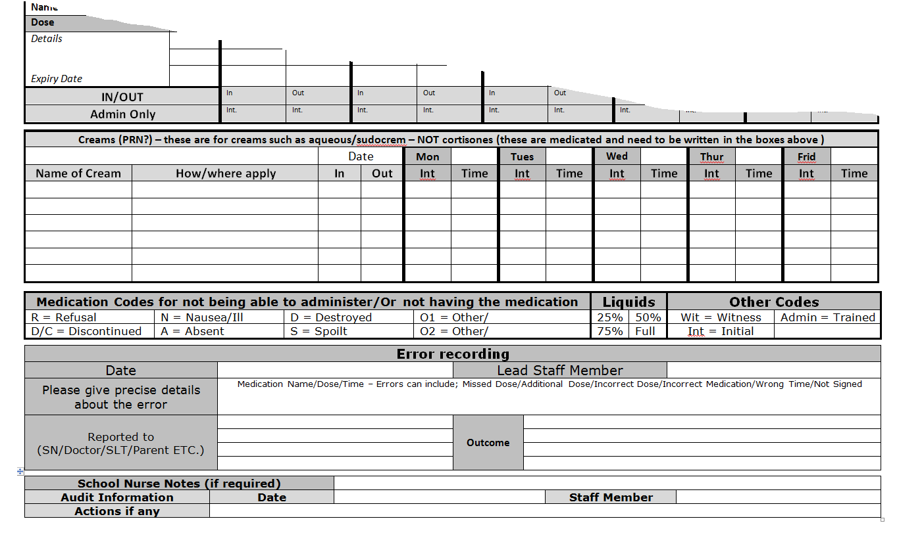
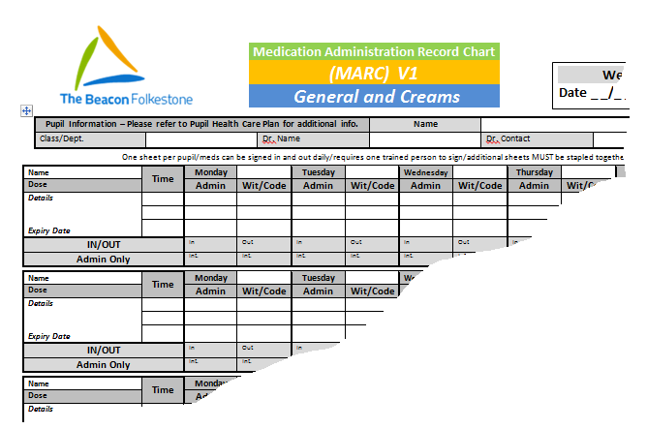

Appendix 5- Height and Weight Chart-SAMPLE

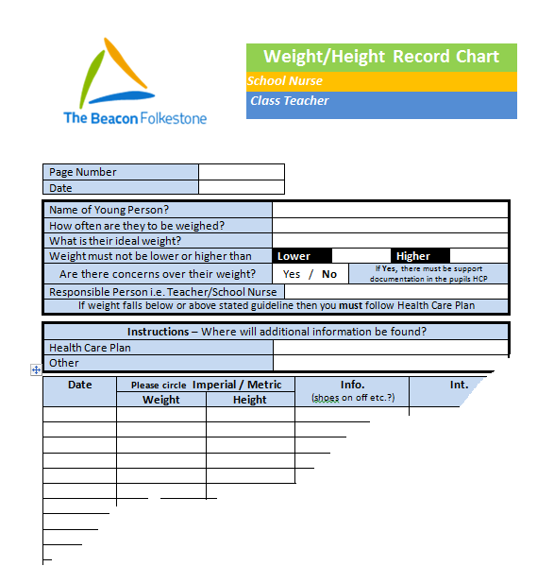

Appendix 6- Epilepsy Recording Sheet-SAMPLE

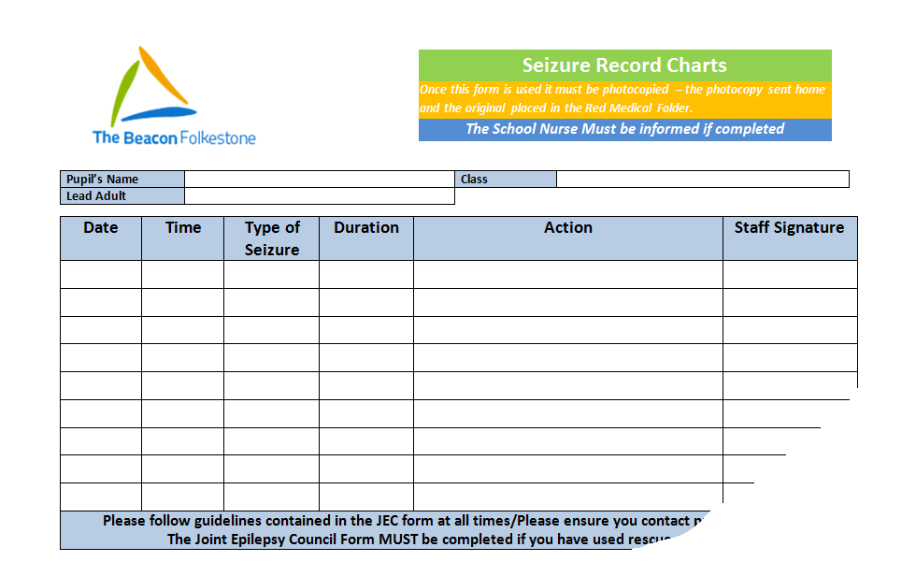

The Beacon Equality Statement

The Beacon Folkestone is committed to ensuring equality of opportunity to all pupils, staff and visitors. Our Core Values are at the foremost of everything we do and we ensure all at The Beacon are treated equally regardless of age, disability, race, colour, ethnicity, nationality, religious belief, gender, gender identity, transgender, sexual orientation or marital status.
The Beacon strives to be an all-inclusive environment and is always looking for opportunities to broaden the knowledge and experiences of everyone who is involved with both our services, and the staff and clients of those using the services of our multi-agency hub.
Our aims for this year are to ensure there are more equal opportunities for pupils, staff, their families and the wider community, regardless of their disability and this forms an integral part of our School Improvement Plan.
The aims for 2016-2019 are to build and improve schemes to help bring down barriers for disabled children and young people and to broaden the experience of life both inside and outside the school community for all staff & pupils.

UPDATE SCHEDULE

Version | Reviewed | Reason for Update | Next review date | Governors agreement
1 | Sept 2016 | Annual renewal/transfer | Sept 2017 | Sept 2016
2 | Sept 2017 | Reviewed/updated | Sept 2018 | Agreed with Governors 13.11.17
3 | Sept 2018 | Annual Review | Sept 2019 | Sent to Governors

