Tuesday 8th November 2022

Dear Parents/Carers,
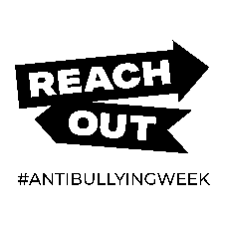
Anti-Bullying Week 14th - 18th November 2022
The Anti-Bullying Alliance’s focus for this year’s Anti-Bullying week is ‘Reach Out by being the change you want to see’. Together we want to enable our pupils and wider community to reflect on our behaviour, set positive examples and create kinder communities.

Over the week we will be building on the lessons already in our school curriculum to look at different aspects associated with this subject. There will be a focus on reaching out for someone you trust if you need to talk, and asking our pupils for their opinions and feedback.

On Monday 14th November, we will be kick starting the week by taking part in Odd Socks Day, it is a fantastic event, which allows everyone to express their personality or make a statement. We would like to challenge your child/young person to come to school wearing some ‘fresh, funky foot fashion’. Anything goes - crazy patterns, vivid colours, fluffy, long, short, football, and character socks are all welcome - make sure you mix it up and say something about you!

As well as Children in Need, we will finish the week with Friendship Friday.

If you would like know more about the Anti-Bullying Alliance and their work, please take a look at their website: www.anti-bullyingalliance.org.uk.

We appreciate your support in helping us to highlight such an important subject, and I look forward to seeing some fashionable feet!

Yours sincerely,

David Quinn
Leader of Learning – Behaviour for Learning

