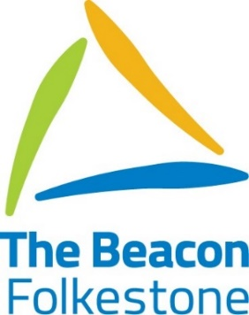
Beacon Newsletter Autumn 2019

Dear Parents/Carers,
I can’t believe that we are almost at the end of term 2 already. We have had an enjoyable but very busy term. At the time of writing we are busy rehearsing for the Christmas performances and we are very much looking forward to welcoming many of you to the school on Tuesday and Wednesday to join us in celebrating the festive season and the efforts and achievement of our young people. It is worth noting that this year the technical support necessary for the production of our Christmas celebrations has come entirely from our student technical team with the support of our staff. A very big well done and thank you to them as well as to all our performers.
Parental Engagement
In previous terms we have struggled to fit everything we are doing into a newsletter and so we are very pleased to announce that The Beacon, Folkestone now has Facebook. We are using this to publicise events and to be a positive forum for information sharing. We hope that you find it useful and informative. There is always so much news to share and it is important to us that you are kept informed about whole school as well as class events. We also have termly Parent forum meetings which are solution focussed meetings to investigate ways in which we can work together for the benefit of our young people. The next meeting is on February 4th 2020 at 1.00 pm. If you would like to attend or have any questions about the work of the Parent forum please contact our Deputy Headteacher Alison Cole Alison.cole@thebeacon.kent.sch.uk
Beacon Plus
One of the most exciting things to happen so far this year is the launch of Beacon Plus which is our college based 19-25 employability programme. It is situated in Folkestone Business Hub in the town centre and it provides functional skills and employability training as well as work experience. The aim of this provision is to secure employment for our young adults when they move on from education. Beacon Plus will be led by Mrs Winter, our current Assistant Head for Zone 3. Mrs Winter has been growing this project through its initial stages as well as looking after zone 3, but now we really are at the stage where this exciting opportunity will need her full attention. Hence, we will be joined in January by Mrs Zintel-Warner who joins us as Assistant Headteacher for zone 3 on secondment from Aspen 2. We are excited to welcome her to the team!
MAST News
We are also excited to welcome Claire Gregory who joins the MAST team as Zone 1 safeguarding lead. She comes with years of safeguarding experience from the NHS and we are very much looking forward to working with her.
Satellite Provision- Castle Hill
This term saw the launch of our satellite provision at Castle-hill Primary school in which our staff work closely with the mainstream school to provide “Beacon” education for some of our young people in years 4, 5 and 6 who may be able to transition into a mainstream provision in the future. ‘Margate’ class is staffed by our teachers and support staff. It already has its first five pupils who are justifiably proud of their brand-new provision and class.
Beacon Plus and The Castlehill satellite are both part of the service we seek to provide to our young people and the community and we would like to thank all those whose hard work, enthusiasm and effort made both projects a reality.

Coming up in Term
EHCP Meeting- Tuesday 7th January
Eco-Day- Thursday 23rd January
EHCP Meeting- Monday 20th January
Safer Internet Day- Tuesday 11th February

The new term starts for pupils on Monday 6th January at 9.00 am. On behalf of all the staff and pupils at The Beacon, Folkestone, I would like to take this opportunity to thank you for your continuing support and to wish each and every one of you a very Happy Christmas and a Happy New Year.

All the staff at The Beacon Folkestone

