[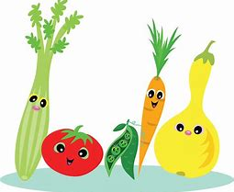](https://www.bing.com/images/search?view=detailV2&ccid=X4xBSUqx&id=EC0E968923EB714D5ED846EA73B8C90535D52507&thid=OIP.X4xBSUqxco0QaYBpltQRCAHaGQ&mediaurl=http%3a%2f%2fworldartsme.com%2fimages%2fhealthy-choices-clipart-1.jpg&exph=1689&expw=2000&q=healthy+choices+images&simid=608010902282701630&selectedIndex=10) [](https://www.bing.com/images/search?view=detailV2&ccid=az6CIQjh&id=CECE2EB61D49E46ADBF61F5C0AF39B4B1BD7DD1D&thid=OIP.az6CIQjh42pCRDqeOQ3d9QHaC2&mediaurl=http%3a%2f%2fwww.co.dakota.mn.us%2fHealthFamily%2fHealthyLiving%2fDietNutrition%2fPublishingImages%2fSmartChoices.gif&exph=676&expw=1751&q=healthy+choices+images&simid=608026394168987492&selectedIndex=2) [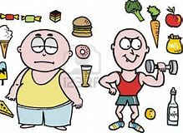](https://www.bing.com/images/search?view=detailV2&ccid=FvecUPOw&id=221828A3A5AAA81246077D420B2B008E5AE4C5E4&thid=OIP.FvecUPOwu0OfSeOYX3jKIQHaFB&mediaurl=http%3a%2f%2fwww.clipartkid.com%2fimages%2f547%2f13216641-cartoon-of-lazy-overweight-man-with-junk-food-PAoO2a-clipart.jpg&exph=813&expw=1200&q=healthy+choices+images&simid=608028339807849017&selectedIndex=136) 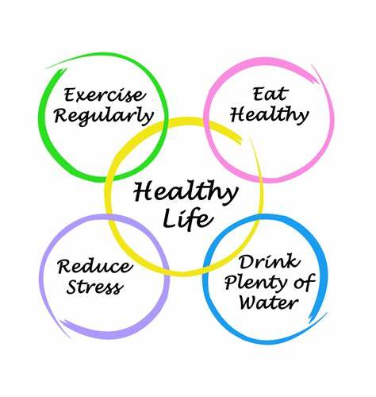

MAIN SCHOOL

|  |
| --- |
| Mon |
| [Image result for cumbrland sausage in gravy](https://www.bing.com/images/search?view=detailV2&ccid=Wig4dsva&id=48582A5A5C98553F194D9DE09299484CBF0ABD89&thid=OIP.Wig4dsvayVuewS2I5S_UqAHaFj&mediaurl=https%3a%2f%2fi.pinimg.com%2f736x%2ff1%2f85%2f61%2ff185619e5a17a81d9d6fca6a778f7a5f--london-city-cumberland-sausage.jpg&exph=552&expw=736&q=cumbrland+sausage+in+gravy&simid=608005486369311159&selectedIndex=0)  **Cumberland Sausage[1] (Gluten Free Option Available on Request)**  C:\Users\john.healey\AppData\Local\Microsoft\Windows\Temporary Internet Files\Content.MSO\8C56A9CA.tmp  **Macaroni Cheese[2] (Gluten free Option Available[3])**  [Image result for mashed potato images](https://www.bing.com/images/search?view=detailV2&ccid=sEvmGW5v&id=C4DD7CE0AFCAC4EF52F21DD63E43256C29F50EF1&thid=OIP.sEvmGW5vwCexYlXyTY72gwHaE8&mediaurl=http%3a%2f%2fcdn.taste.com.au%2fimages%2frecipes%2fsfi%2f2004%2f06%2f7752.jpg&exph=2000&expw=3000&q=mashed+potato+images&simid=608041207581970142&selectedIndex=0)  **Mashed Potato**  [Image result for baked bean images](https://www.bing.com/images/search?view=detailV2&ccid=e%2fhj4Gfp&id=E4B8D2EBE2D9C1D06F32F9A6E9869A346D3F397F&thid=OIP.e_hj4GfpnO0X-nFze0nl7gHaE6&mediaurl=http%3a%2f%2fsimply-bbq.com%2fwp-content%2fuploads%2f2017%2f01%2fBaked-Beans.jpg&exph=2848&expw=4288&q=baked+bean+images&simid=607991467553786142&selectedIndex=10)**&** Image result for garden poeas  **Baked Beans & Garden Peas**  See the source image  **Salad Tray**  [Image result for bread](https://www.bing.com/images/search?view=detailV2&ccid=uihjRKIq&id=C4E23887071005BB4D8854481D97ACB41B38A68A&thid=OIP.uihjRKIqa57EHkCDLEreBwHaE7&mediaurl=http%3a%2f%2fwww.azhariahkamin.com%2fwp-content%2fuploads%2f2015%2f11%2fsliced-bread.jpg&exph=853&expw=1280&q=bread&simid=608008759121084633&selectedIndex=3)  **Bread[4]**  [Image result for banana mousse images](https://www.bing.com/images/search?view=detailV2&ccid=t7CrgonQ&id=F056A15AF7FE70E6C3678FE5D3B6EE99CFB08860&thid=OIP.t7CrgonQtoAALGcSorSkmQHaD8&mediaurl=http%3a%2f%2fwww.mundoboaforma.com.br%2fwp-content%2fuploads%2f2017%2f02%2fmousse-de-banana-light-620x330.jpg&exph=330&expw=620&q=banana+mousse+images&simid=608016305386490741&selectedIndex=6)  **Banana Mousse[5]**  [Image result for yoghurts images](https://www.bing.com/images/search?view=detailV2&ccid=HaNoOXRi&id=E9CD58AD36E85C29197EAB17F9454AAE415B245C&thid=OIP.HaNoOXRi-RHziitVBAvsMwAAAA&mediaurl=http%3a%2f%2fwww.ecured.cu%2fimages%2f5%2f58%2fYogurt2.jpeg&exph=246&expw=205&q=yoghurts+images&simid=607990823300828934&selectedIndex=55)  **Yoghurt[6]**  [Image result for fresh fruit images](https://www.bing.com/images/search?view=detailV2&ccid=bJWJMHoQ&id=3D187603DA6F8B49A1B35858E68EFA533A9F5EB2&thid=OIP.bJWJMHoQB81FpBNu43RMogHaEP&mediaurl=http%3a%2f%2fwww.pngpix.com%2fwp-content%2fuploads%2f2016%2f10%2fPNGPIX-COM-Fruits-PNG-Transparent-Image.png&exph=1077&expw=1880&q=fresh+fruit+images&simid=608032377119244976&selectedIndex=37)  **Fresh Fruit** |

**ALLERGEN INFORMATION**

[](https://www.bing.com/images/search?view=detailV2&ccid=X4xBSUqx&id=EC0E968923EB714D5ED846EA73B8C90535D52507&thid=OIP.X4xBSUqxco0QaYBpltQRCAHaGQ&mediaurl=http%3a%2f%2fworldartsme.com%2fimages%2fhealthy-choices-clipart-1.jpg&exph=1689&expw=2000&q=healthy+choices+images&simid=608010902282701630&selectedIndex=10)[](https://www.bing.com/images/search?view=detailV2&ccid=az6CIQjh&id=CECE2EB61D49E46ADBF61F5C0AF39B4B1BD7DD1D&thid=OIP.az6CIQjh42pCRDqeOQ3d9QHaC2&mediaurl=http%3a%2f%2fwww.co.dakota.mn.us%2fHealthFamily%2fHealthyLiving%2fDietNutrition%2fPublishingImages%2fSmartChoices.gif&exph=676&expw=1751&q=healthy+choices+images&simid=608026394168987492&selectedIndex=2)[](https://www.bing.com/images/search?view=detailV2&ccid=FvecUPOw&id=221828A3A5AAA81246077D420B2B008E5AE4C5E4&thid=OIP.FvecUPOwu0OfSeOYX3jKIQHaFB&mediaurl=http%3a%2f%2fwww.clipartkid.com%2fimages%2f547%2f13216641-cartoon-of-lazy-overweight-man-with-junk-food-PAoO2a-clipart.jpg&exph=813&expw=1200&q=healthy+choices+images&simid=608028339807849017&selectedIndex=136)

|  |
| --- |
| TUES |
| **Packed Lunch Day**  **School Production** |

**ALLERGEN INFORMATION**

[](https://www.bing.com/images/search?view=detailV2&ccid=X4xBSUqx&id=EC0E968923EB714D5ED846EA73B8C90535D52507&thid=OIP.X4xBSUqxco0QaYBpltQRCAHaGQ&mediaurl=http%3a%2f%2fworldartsme.com%2fimages%2fhealthy-choices-clipart-1.jpg&exph=1689&expw=2000&q=healthy+choices+images&simid=608010902282701630&selectedIndex=10)[](https://www.bing.com/images/search?view=detailV2&ccid=az6CIQjh&id=CECE2EB61D49E46ADBF61F5C0AF39B4B1BD7DD1D&thid=OIP.az6CIQjh42pCRDqeOQ3d9QHaC2&mediaurl=http%3a%2f%2fwww.co.dakota.mn.us%2fHealthFamily%2fHealthyLiving%2fDietNutrition%2fPublishingImages%2fSmartChoices.gif&exph=676&expw=1751&q=healthy+choices+images&simid=608026394168987492&selectedIndex=2)[](https://www.bing.com/images/search?view=detailV2&ccid=FvecUPOw&id=221828A3A5AAA81246077D420B2B008E5AE4C5E4&thid=OIP.FvecUPOwu0OfSeOYX3jKIQHaFB&mediaurl=http%3a%2f%2fwww.clipartkid.com%2fimages%2f547%2f13216641-cartoon-of-lazy-overweight-man-with-junk-food-PAoO2a-clipart.jpg&exph=813&expw=1200&q=healthy+choices+images&simid=608028339807849017&selectedIndex=136)

|  |
| --- |
| WED |
| **Packed Lunch Day**  **School Production** |

**ALLERGEN INFORMATION**

1. **Contains Gluten (Wheat) & Sulphites**
2. **Contains Gluten (Wheat), Milk & Mustard**
3. **Contains Milk & Mustard**
4. **Contains Gluten (Wheat)**
5. **Contains Milk**
6. **Contains Milk**