**My School is Closed.**

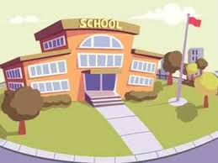



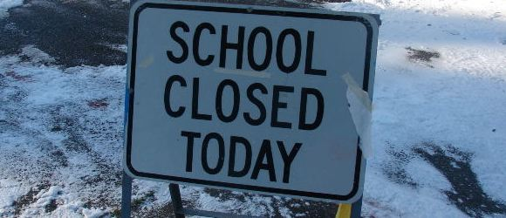

**My school is closed because of the Coronavirus. All schools have been told to close by the government, this is to keep the virus from spreading.**

**My teachers and friends will be told to stay at home too.**

[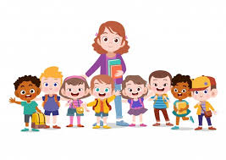](https://www.google.co.uk/imgres?imgurl=https%3A%2F%2Fimg.freepik.com%2Ffree-vector%2Fteacher-with-kids-school_97632-630.jpg%3Fsize%3D626%26ext%3Djpg&imgrefurl=https%3A%2F%2Fwww.freepik.com%2Ffree-photos-vectors%2Fteacher&tbnid=xLRPYfZvCl525M&vet=12ahUKEwjp7fjl5p7oAhUBxOAKHSAfCyIQMygkegQIARBk..i&docid=djeqU-CLBYw4YM&w=626&h=442&q=teacher%20and%20pupils%20cartoon&hl=en-GB&safe=strict&ved=2ahUKEwjp7fjl5p7oAhUBxOAKHSAfCyIQMygkegQIARBk)

[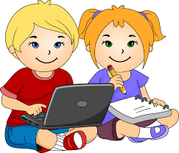](https://www.google.co.uk/imgres?imgurl=https%3A%2F%2Fwebstockreview.net%2Fimages%2Fclipart-child-writing-17.png&imgrefurl=https%3A%2F%2Fwebstockreview.net%2Fexplore%2Fclipart-writing-cartoon-child%2F&tbnid=iC4o7I4ziLmnSM&vet=12ahUKEwj25M-W6J7oAhUcPhoKHd_dAZAQMyhOegUIARDTAQ..i&docid=CQtkjbWIfBKlHM&w=750&h=641&q=writing%20cartoon&hl=en-GB&safe=strict&ved=2ahUKEwj25M-W6J7oAhUcPhoKHd_dAZAQMyhOegUIARDTAQ)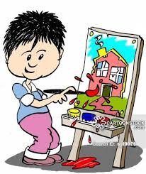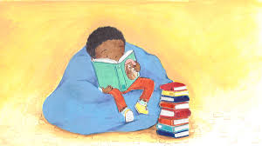

**We do not know how long my school will be closed. The government will decide when schools open again and tell my family/carers. Until then I will try to be happy at home. My family and teacher will be happy if I try to complete some school activities at home.**

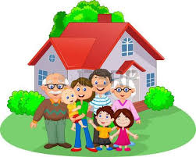

**When I am at home, I will try to do some activities. I might try to do some reading, writing and maths, and other activities. My teacher may like to see what activities I have done when we return to school.**

[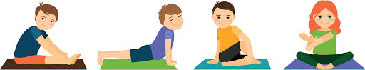](https://www.google.co.uk/imgres?imgurl=https%3A%2F%2Fwww.yogabliss.co.uk%2Fimages%2Fyoga%2Fyoga-children-002c.png&imgrefurl=https%3A%2F%2Fwww.yogabliss.co.uk%2Fyoga-for-children.php&tbnid=QrvqPYP-bx5FZM&vet=12ahUKEwiF54D58J7oAhVC9hoKHbuXBBIQMygcegQIARBo..i&docid=o5NAN55_Ek9ulM&w=1417&h=273&q=Yoga%20children&ved=2ahUKEwiF54D58J7oAhVC9hoKHbuXBBIQMygcegQIARBo)