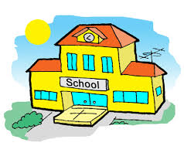[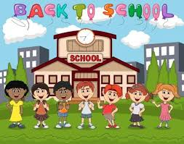](https://www.google.co.uk/imgres?imgurl=https%3A%2F%2Fus.123rf.com%2F450wm%2Fbubululu%2Fbubululu1708%2Fbubululu170800002%2F83599730-stock-vector-students-in-front-of-school-with-balloon-back-to-school-cartoon.jpg%3Fver%3D6&imgrefurl=https%3A%2F%2Fwww.123rf.com%2Fstock-photo%2Fback_to_school_cartoon.html&tbnid=-A2CXg6nf7QKQM&vet=12ahUKEwjlsIaIiJ_oAhXM0OAKHfl_CJ0QMygUegQIARBF..i&docid=l3ov31_jDTbrcM&w=450&h=354&q=back%20to%20school%20cartoon&safe=strict&ved=2ahUKEwjlsIaIiJ_oAhXM0OAKHfl_CJ0QMygUegQIARBF)

The Government has said it is safe to go back to school. My friends and teachers will be pleased to see me.

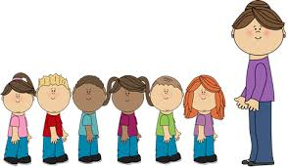

Going back to school.

[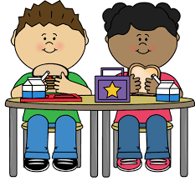](https://www.google.co.uk/imgres?imgurl=http%3A%2F%2Fclipart-library.com%2Fimg%2F1185761.png&imgrefurl=http%3A%2F%2Fclipart-library.com%2Fschool-lunch-cliparts.html&tbnid=0ptcvBaU7cp0eM&vet=12ahUKEwiNl5a7jZ_oAhUJQBoKHUu-DUgQMygbegQIARBA..i&docid=TvDVy5zzloyQRM&w=450&h=419&q=school%20dinner%20cartoons%20clipart&safe=strict&ved=2ahUKEwiNl5a7jZ_oAhUJQBoKHUu-DUgQMygbegQIARBA)[](https://www.google.co.uk/imgres?imgurl=http%3A%2F%2Fclipart-library.com%2Fimages%2F6cpoL85zi.png&imgrefurl=http%3A%2F%2Fclipart-library.com%2Fschool-bag-clipart.html&tbnid=-FLxL_FaNDbNEM&vet=10CDcQMyh5ahcKEwiomrqaip_oAhUAAAAAHQAAAAAQAw..i&docid=DdlfBIHoWTSLAM&w=555&h=455&q=school%20bags%20cartoons&safe=strict&ved=0CDcQMyh5ahcKEwiomrqaip_oAhUAAAAAHQAAAAAQAw)

It might take me time to get used to the school routine and what school is like. I will have my lunches at school this might be school dinners or packed lunch.

I will try to remember my routine and what I need to take to school. Adults will support me with this.

[](https://www.google.co.uk/imgres?imgurl=https%3A%2F%2Fi.pinimg.com%2F564x%2Fd5%2F4c%2F67%2Fd54c674f05bde405dca2ef860321a796.jpg&imgrefurl=https%3A%2F%2Fwww.pinterest.com%2Fpin%2F317222367492694823%2F&tbnid=Efm7iSt8EaeRqM&vet=10CDYQMyh-ahcKEwiotZTujZ_oAhUAAAAAHQAAAAAQAw..i&docid=6slKypDbmOipMM&w=532&h=902&q=classroom%20cartoons%20clipart&safe=strict&ved=0CDYQMyh-ahcKEwiotZTujZ_oAhUAAAAAHQAAAAAQAw)

All children will return to school. Going back to school is important so that all children can continue to learn.

[](https://www.google.co.uk/imgres?imgurl=http%3A%2F%2Fclipart-library.com%2Fnewimages%2Fkids-clipart-2-9.jpg&imgrefurl=http%3A%2F%2Fclipart-library.com%2Fkids-clipart-2.html&tbnid=Jn6V-bIqr2uvxM&vet=12ahUKEwjZtKXljp_oAhXM_IUKHRYlDvIQMygXegQIARAx..i&docid=NOoZl7MMrrcxxM&w=1167&h=410&q=happy%20children%20cartoons%20clipart&safe=strict&ved=2ahUKEwjZtKXljp_oAhXM_IUKHRYlDvIQMygXegQIARAx)

School might feel different to home, it may smell different and there will be different noises. This is ok. If school feels different, I will try to ask an adult to help.