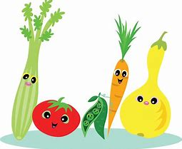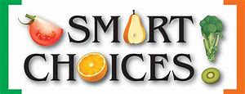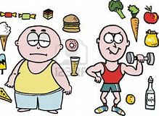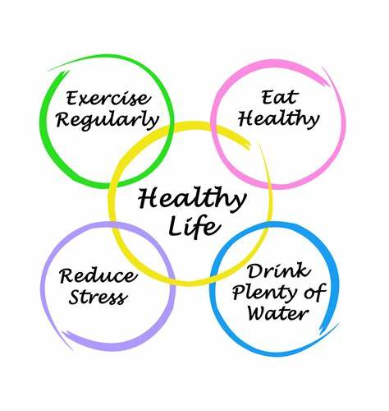

MAIN SCHOOL

Mon
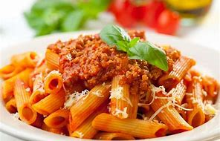 & 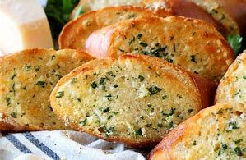
Pasta Bolognaise(Gluten Free Pasta Available on Request) with Garlic Bread
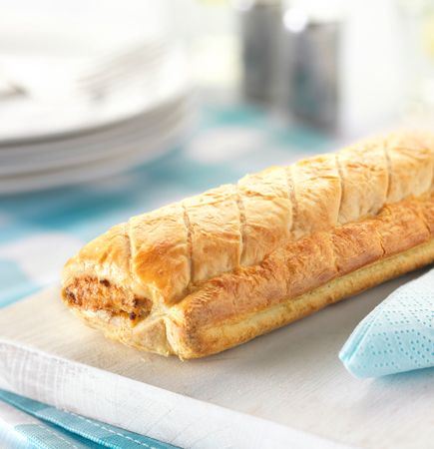& 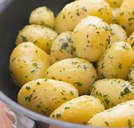
Vegetarian Sausage Rolls with New Potatoes and Gravy
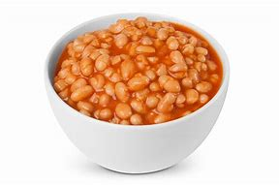& 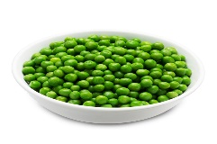
Baked Beans & Garden Peas
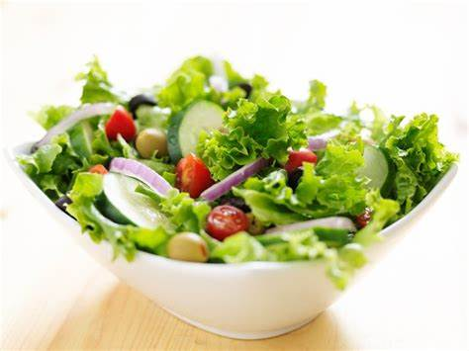
Salad Tray
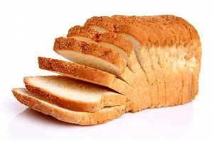
Bread
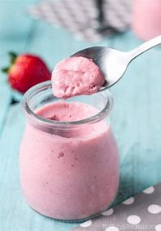
Strawberry Mousse
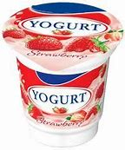
Yoghurt
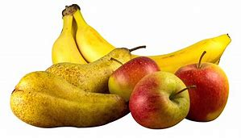
Fresh Fruit
ALLERGEN INFORMATION
Tue
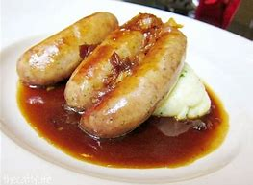
Cumberland Sausage with Onion Gravy (Gluten Free Option Available on Request)
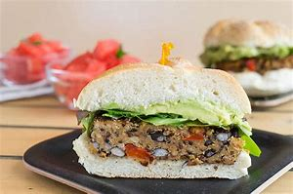
Spiced Bean Burgers in a Bap With Tomato Salsa
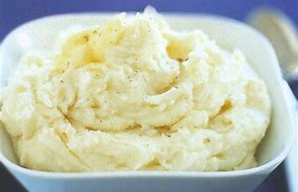
Mashed Potatoes
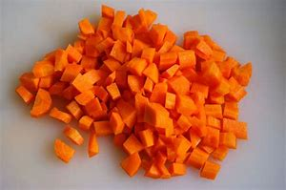&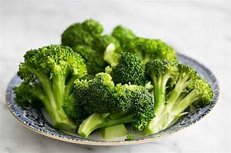
Diced Carrots & Broccoli Florets
Salad Tray
Bread
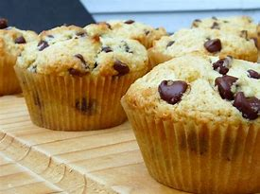
Reduced Sugar/Gluten Free Chocolate Chip Muffins
Yoghurt

Fresh Fruit
ALLERGEN INFORMATION

Wed
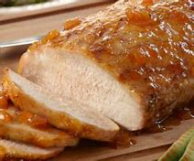&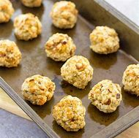with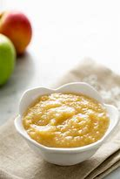
Roast Loin Of Pork with Sage & Onion Stuffing and Apple Sauce
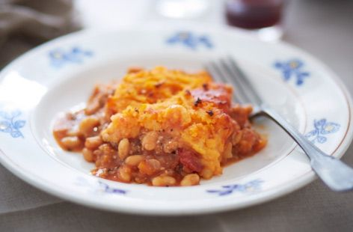
Vegetarian Cottage Pie
& 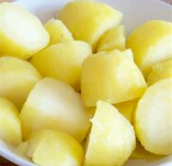
Roast Potatoes & Boiled Potatoes
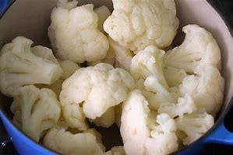&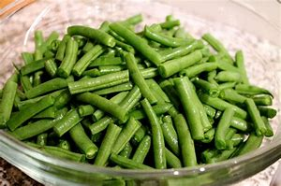
Cauliflower Florets & Green Beans
Salad Tray
Bread
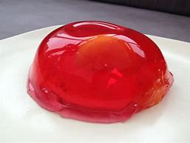
Fruit Jelly
Yoghurt
Fresh Fruit
ALLERGEN INFORMATION

Thu
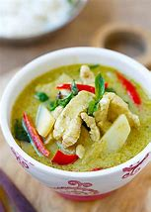&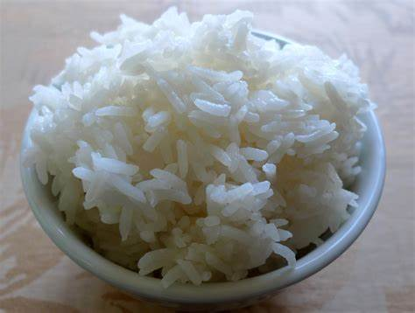
Thai Style Green Chicken Curry with Jasmine Rice
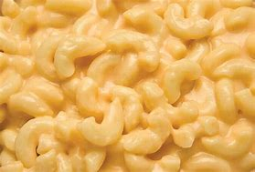
Macaroni Cheese (Gluten free Option Available)
&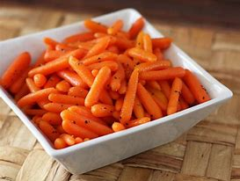
Garden Peas and Baby Carrots

Salad Tray
Bread
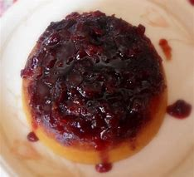

Gluten Free/Reduced Sugar Cherry Sponge & Custard
Yoghurt
Fresh Fruit
ALLERGEN INFORMATION

Fri
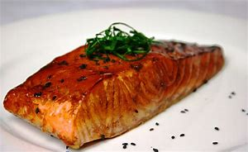
Baked Teryaki Salmon
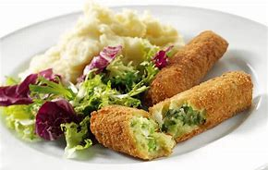&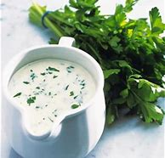
Glamorgan Sausages with a Parsley Sauce
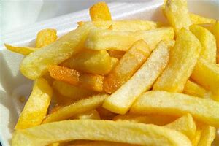
Chips
&
Baked Beans & Broccoli Florets
Salad Tray
Bread
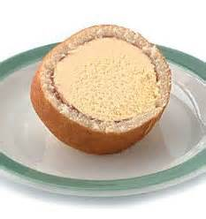
Ice Cream Roll
Yoghurt
Fresh Fruit
ALLERGEN INFORMATION

Contains Gluten (Wheat)
Contains Gluten (Wheat)
Contains Gluten (Wheat) & Eggs
Contains Sulphites
Contains Gluten (Wheat)
Contains Milk
Contains Milk
Contains Gluten (Wheat) & Sulphites
Contains Gluten (Wheat)
Contains Gluten (Wheat)
Contains Gluten (Wheat)
Contains Eggs & Milk
Contains Milk
Contains Gluten (Wheat)
Contains Sulphites
Contains Sulphites
Contains Gluten (Wheat)
Contains Milk
Contains Fish
Contains Gluten (Wheat), Milk & Mustard
Contains Milk & Mustard
Contains Gluten (Wheat)
Contains Eggs
Contains Milk
Contains Milk
Contains Soya Bean
Contains Gluten (Wheat) & Milk
Contains Milk
Contains Gluten (Wheat)
Contains Eggs, Milk & Gluten (Wheat)
Contains Milk

