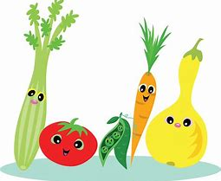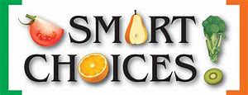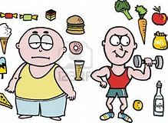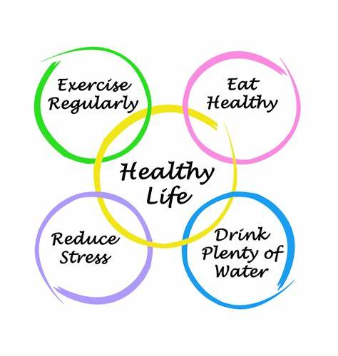

MAIN SCHOOL

Mon
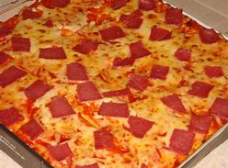
Homemade Ham & Cheese Pizza (Gluten or Dairy Free Option Available on request)
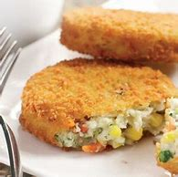&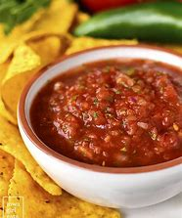
Breaded Vegetable Burger with Tomato & Onion Salsa
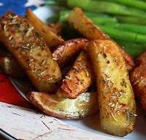
Herby Jacket Wedges
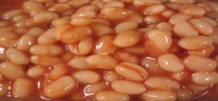& 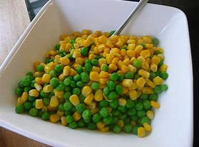
Baked Beans & Garden Peas & Sweetcorn
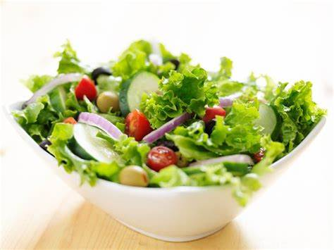
Salad Tray
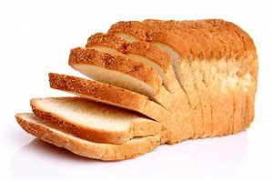
Bread
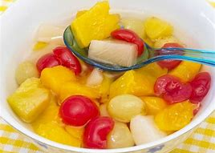&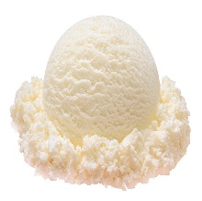
Fruit and Ice Cream
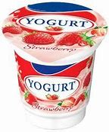
Yoghurt
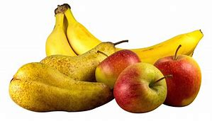
Fresh Fruit
ALLERGEN INFORMATION
Tue
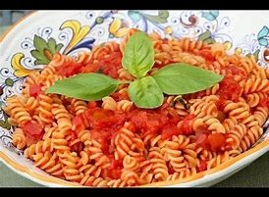
Chicken & Tomato Pasta with Tricolour Fusilli (Gluten free alternative available)
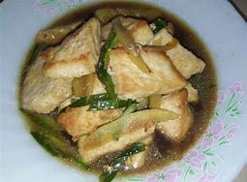&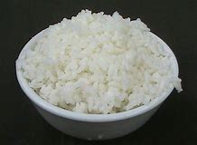
Quorn Strips in Hoisin Sauce with Spring Onions with Steamed Rice

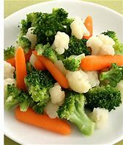
Cauliflower Broccoli & Baby Carrots & Sweetcorn
Salad Tray
Bread
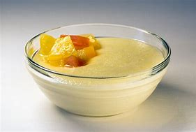
Semolina or Rice Pudding
Yoghurt
Fresh Fruit

ALLERGEN INFORMATION

Wed
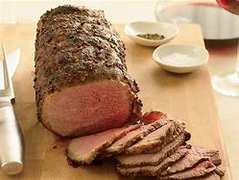&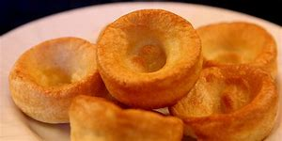
Roast Topside Of Beef with Yorkshire Pudding
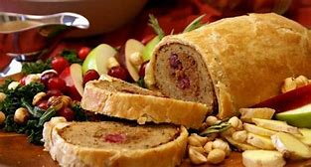
Vegetarian Roast Wrapped in Pastry
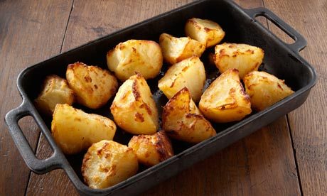& 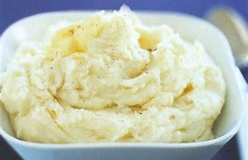
Roast Potatoes & Mashed Potatoes
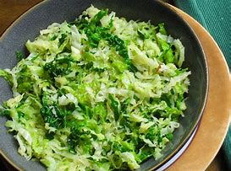&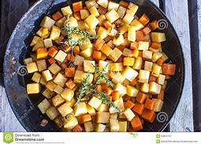
Savoy Cabbage & Carrot & Swede
Salad Tray
Bread
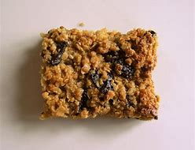
Reduced Sugar Fruit Flapjack
Yoghurt
Fresh Fruit
ALLERGEN INFORMATION

Thu
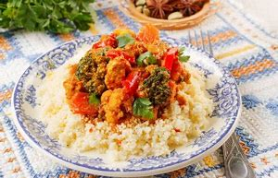
Moroccan Chicken with Herby Couscous (Gluten free alternative available)
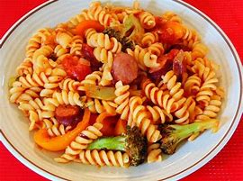&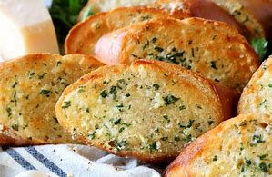
Vegetable & Tomato Pasta with Side Salad & Garlic Bread
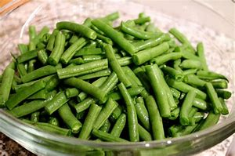&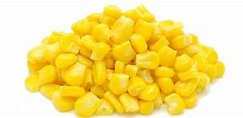
Green Beans & Sweecorn

Salad Tray
Bread
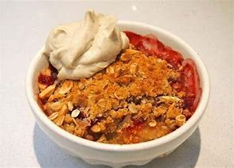
Reduced Sugar Gluten Free Fruit Crumble & Cream
Yoghurt
Fresh Fruit
ALLERGEN INFORMATION

Fri
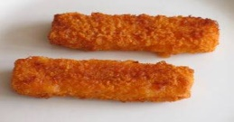
Fish Fingers
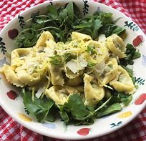
Vegetable Tortellini
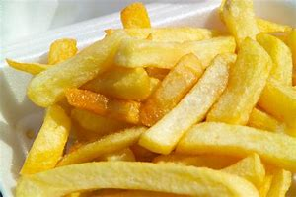
Chips
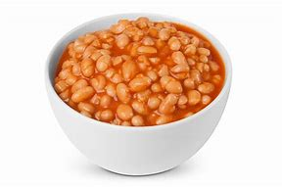& 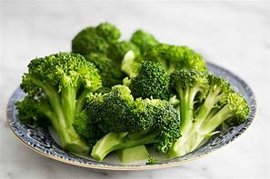
Baked Beans & Broccoli
Salad Tray
Bread
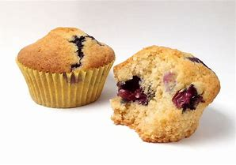
Gluten Free/Reduced Sugar Blueberry Muffins
Yoghurt
Fresh Fruit

ALLERGEN INFORMATION

Contains Gluten (Wheat), Soya Bean & Milk
Contains Gluten (Wheat)
Contains Gluten (Wheat)
Contains Milk
Contains Milk
Contains Gluten (Wheat)
Contains Soya Bean
Contains Gluten (Wheat)
Contains Milk
Contains Milk
Contains Gluten (Wheat), Eggs and Milk
Contains Gluten (Wheat) and Eggs
Contains Sulphites
Contains Sulphites
Contains Gluten (Wheat)
Contains Gluten (Oats)
Contains Milk
Contains Gluten (Wheat)
Contains Gluten(Wheat)
Contains Gluten (Wheat)
Contains Gluten (Wheat)
Contains Milk
Contains Milk
Contains Gluten (Wheat), Eggs, Milk & Mustard
Contains Gluten(Wheat)
Contains Eggs
Contains Milk

