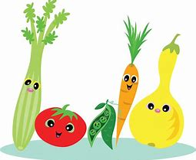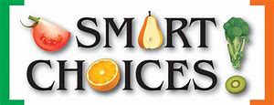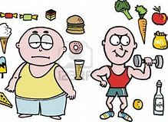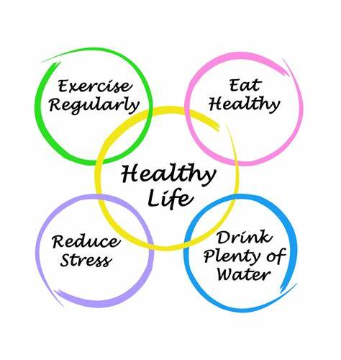

MAIN SCHOOL

Mon
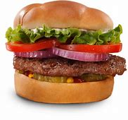
Reduced Fat Beef Burgers in a Bap (Gluten Free Roll Available on Request)
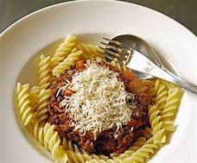&
Vegetarian Ragu with Pasta (Gluten Free Pasta Available on Request)
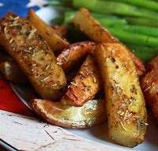
Potato Wedges
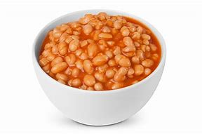& 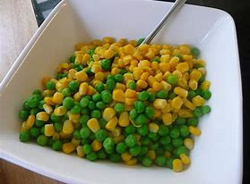
Baked Beans & Garden Peas & Sweetcorn
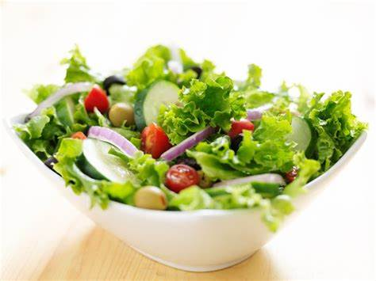
Reduced Fat Coleslaw & Salad Tray
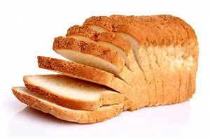
Bread
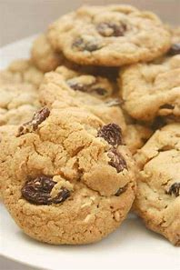
Gluten Free/Reduced Sugar Cinnamon & Raisin Cookie
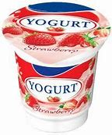
Yoghurt
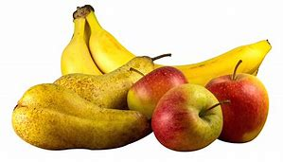
Fresh Fruit
ALLERGEN INFORMATION
Tue
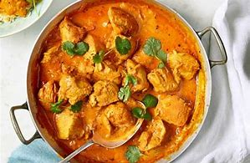&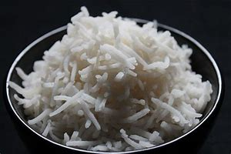
Chicken Curry of The Week with Basmati Rice
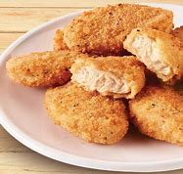&
Quorn Vegan Nuggets with Barbeque Sauce
New Potatoes
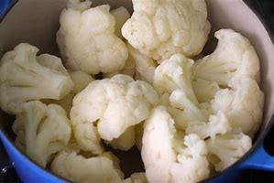&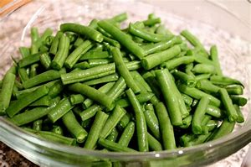
Cauliflower Florets & Green Beans
Salad Tray
Bread
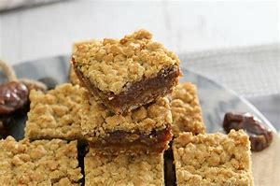&
Gluten Free Date Slice & Custard
Yoghurt

Fresh Fruit

ALLERGEN INFORMATION

Wed
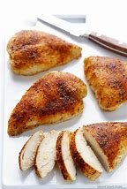&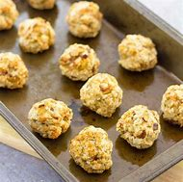
Roast Chicken Breast with Sage & Onion Stuffing Balls
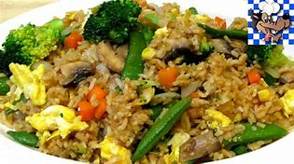
Vegetarian Fried Rice
& 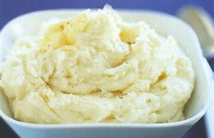
Roast Potatoes & Mashed Potatoes
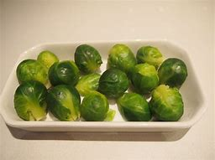&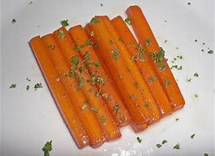
Brussel Sprouts & Baton Carrot
Salad Tray
Bread
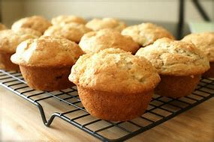
Gluten Free/Reduced Sugar Spiced Banana Muffins
Yoghurt
Fresh Fruit
ALLERGEN INFORMATION

Thu
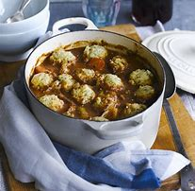
Beef Stew With Dumplings (Gluten Free Option Available on request)
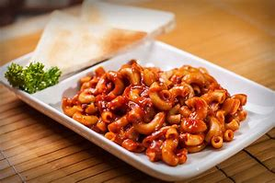
Macaroni with Tomato Sauce (Gluten Free alternative available)
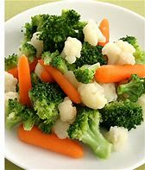
Mixed Vegetables
Salad Tray
Bread
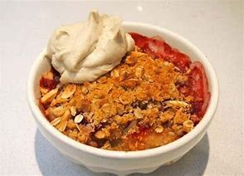&
Gluten Free/Reduced Sugar Fruit Crumble with Iced Cream

Yoghurt
Fresh Fruit
ALLERGEN INFORMATION

Fri
Fish In Breadcrumbs (Gluten Free Option Available on Request)
Vegetarian Quiche (Gluten Free Option Available on Request)
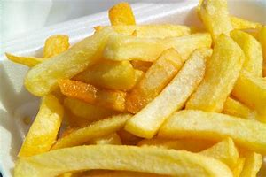
Chips
&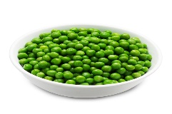
Baked Beans & Garden Peas
Salad Tray
Bread
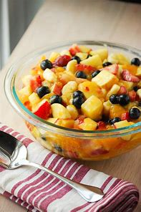
Fruit Salad

Yoghurt
Fresh Fruit
ALLERGEN INFORMATION

Contains (Gluten (Wheat)
Contains Gluten (Wheat) & Egg
Contains Eggs, Milk & Mustard
Contains Gluten (Wheat)
Contains Eggs
Contains Milk
Contains Mustard
Contains Soya Bean
Contains Gluten (Wheat)
Contains Milk
Contains Milk
Contains Gluten (Wheat)
Contains Soya Bean
Contains Sulphites
Contains Sulphites
Contains Gluten (Wheat)
Contains Eggs
Contains Milk
Contains Gluten (Wheat)
Contains Gluten (Wheat)
Contains Gluten (Wheat)
Contains Milk
Contains Milk
Contains Gluten (Wheat)
Contains Gluten (Wheat), Milk, Eggs & Mustard
Contains Milk, Eggs & Mustard
Contains Gluten (Wheat)
Contains Milk

